**Segment Tree - Min**

**Problem**

Build a segment tree with max build, query and update.

Example

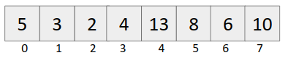

**Structure**

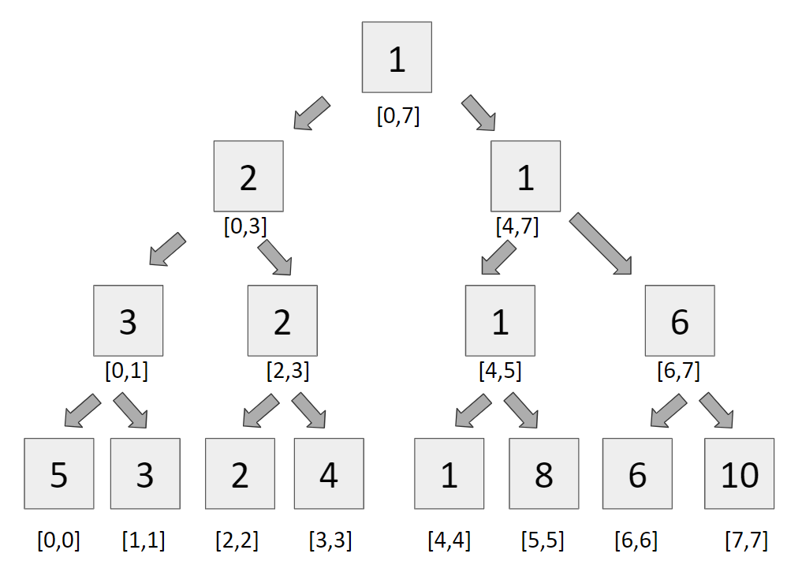

**Approach**

**Building a segment tree**

It is very simple to build a segment tree, we use divide and conquer approach to build the segment tree.

**Query**

For query, we see two types of segments

* Complete overlapping segments - When our st Partial overlapping segments and en lies completely in the range [l,r], it is called complete overlapping segment.
* Partial overlapping segments - When our st and en does not lie completely in the range [l,r], it is called partial overlapping segment.

**Code**

**#include<bits/stdc++.h>**

**using namespace std;**

**#define int long long**

**#define endl "\n"**

**const int N = 1e5+2, MOD = 1e9+7;**

**int tree[4*N], a[N];**

**void build(int node, int st, int en){**

**if(st == en){**

**tree[node] = a[st];**

**return;**

**}**

**int mid = (st + en)/2;**

**build(2*node, st, mid);**

**build(2*node+1, mid+1, en);**

**tree[node] = min(tree[2*node], tree[2*node+1]);**

**}**

**int query(int node, int st, int en, int l, int r){**

**if(en < l || st > r){**

**return MOD;**

**}**

**if(l <= st && en <= r)**

**return tree[node];**

**int mid = (st + en)/2;**

**int q1 = query(2*node, st, mid, l, r);**

**int q2 = query(2*node+1, mid+1, en, l, r);**

**return min(q1, q2);**

**}**

**void update(int node, int st, int en, int idx, int val){**

**if(st == en){**

**a[st] = val;**

**tree[node] = val;**

**return;**

**}**

**int mid = (st+en)/2;**

**if(idx <= mid){**

**update(2*node, st, mid, idx, val);**

**}**

**else{**

**update(2*node+1, mid+1, en, idx, val);**

**}**

**tree[node] = min(tree[2*node], tree[2*node+1]);**

**}**

**signed main(){**

**int n,m;**

**cin >> n >> m;**

**for(int i=0; i<n; i++){**

**cin >> a[i];**

**}**

**build(1,0,n-1);**

**while(m--){**

**int type;**

**cin >> type;**

**if(type == 1){**

**int idx,val;**

**cin >> idx >> val;**

**update(1,0,n-1,idx,val);**

**}**

**else{**

**int l,r;**

**cin >> l >> r;**

**int ans = query(1,0,n-1,l,r-1);**

**cout << ans << endl;**

**}**

**}**

**return 0;**

**}**